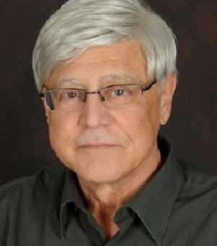

Larry Migliore

Larry Migliori was born in Rome and attended Rome Public Schools.  He received a Bachelor of Fine Arts in Art Education with a minor in Photography with concentrations in Graphic Design, Photography and Sculpture from Pratt Institute.  He earned a master in Synaesthetic Education from Syracuse University.    He taught drawing, painting, ceramics, photography and creative thinking at Rome Free Academy, as well as art classes at elementary and middle school levels in the Rome district.  His teaching covered every grade level of art education.  Larry also served as a full-time professor teaching photography and art history at Mohawk Valley Community College.  He is a member of the Rome Art Association, the Syracuse Camera Club and the New York State Art Teachers Association. He has exhibited his photography in area shows including Faculty shows in the Rome Public Schools and MVCC, Rome Art Association, Rome Art and Community Center, the Reach Center, the Photo Shoppe and Fusion Art Gallery, and the Syracuse Camera Club.